Q1.

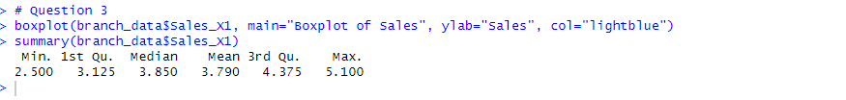Q2.

|  |  |  |  |
| --- | --- | --- | --- |
| **Dataset** | **Variable** | **Variable Type** | **Scale of Measurement** |
| DATA 4.txt | Team | Qualitative | Nominal |
| DATA 4.txt | X1 | Quantitative | Ratio |
| DATA 4.txt | X2 | Quantitative | Ratio |
| DATA 4.txt | X3 | Quantitative | Ratio |
| Exercise.txt | Branch | Qualitative | Nominal |
| Exercise.txt | Sales_X1 | Quantitative | Ratio |
| Exercise.txt | Advertising_X2 | Quantitative | Ratio |
| Exercise.txt | Years_X3 | Quantitative | Ratio |

